RSA International
Indianapolis, IN
October 16, 2014

Zoho Show Instruction Manual

Compiled and edited for RSA International by Kara Pelicano & Lenden Hensley

Table of Contents

What is Zoho Show and what can it offer me? . . . . . . . . . . . . . . . . . . . . . . . . p. 2

Getting started with Zoho Show . . . . . . . . . . . . . . . . . . . . . . . . . . . . . . . . . . . p. 3

How to import a PowerPoint presentation into Zoho . . . . . . . . . . . . . . . . . . . . p. 4

What is Zoho broadcast/remote function and what can it offer me? . . . . . . . . p. 5

How to use the broadcast/remote function . . . . . . . . . . . . . . . . . . . . . . . . . . . p. 6

What is Zoho Show and what can it offer me as an employee of RSA International?

In an effort to cut back on company travel costs, RSA International is now implementing online tools to facilitate virtual meetings and presentations.

Where an RSA employee used to be due to give a presentation to a client in person, that employee may now give the same presentation remotely, from the comfort of their own RSA office. Zoho Show will allow the employee to upload their presentation and broadcast it over the Internet to the client’s own computer. Live video conferencing or phone conferencing will be available to the employee to complete the remote presentation.

RSA will be using Zoho Show to allow employees to upload presentations and share them remotely with colleagues and clients. Zoho Show is an online presentation tool that helps to create and deliver presentations.

Employees can now take presentations anywhere, apply new ideas instantly, review, edit, share, and deliver presentations on the go. RSA Employees will be able to use this remote presentation sharing in place of costly travel for presentations.

Getting started with Zoho Show

In order to utilize Zoho Show’s tools and functions, the employee must first create a free account through the website.
- Go to https://www.zoho.com/docs/online-presentation-tool.html
- Click on the “SIGN UP NOW!” button
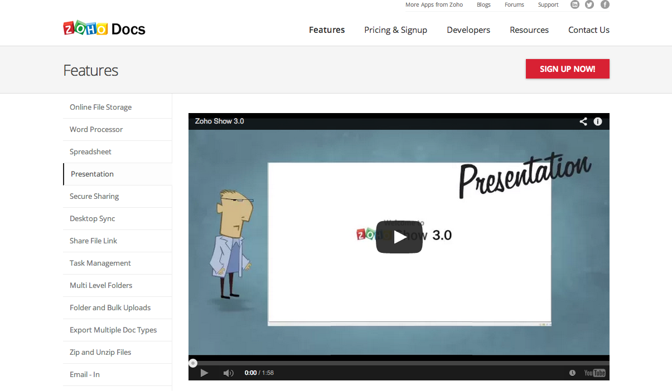

⬅

- Enter the information requested including full name, work email address, a protected password, company name, and work phone number.
- Agree to the Terms of Service and Privacy Policy
- Click “Sign Up” once all pertinent information is filled out completely
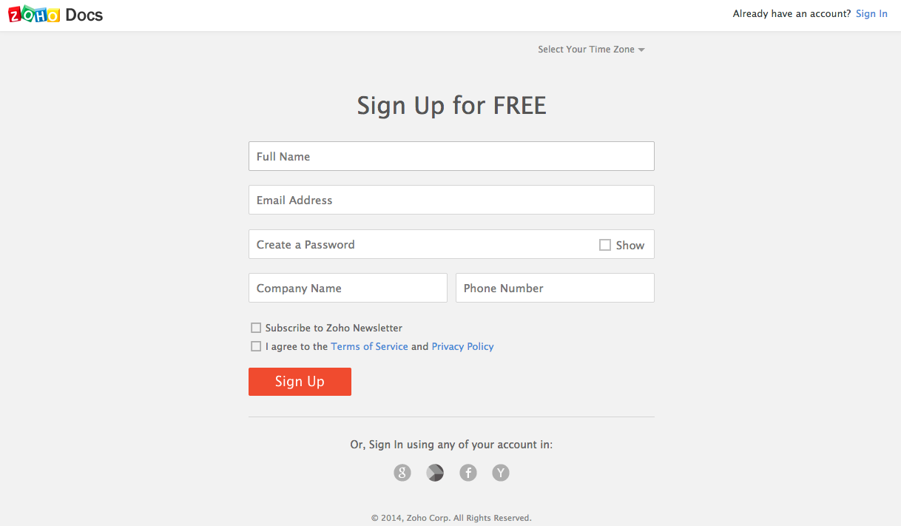

How to import a PowerPoint presentation into Zoho

After the RSA employee creates an account with Zoho Show and is then in need of broadcasting a presentation remotely, the employee can create their presentation in Word, Excel, or PowerPoint as they have previously. The presentation then needs to be imported into Zoho Show.
- If employee is not already logged in, login with your work email and password at https://www.zoho.com/docs/login.html
- Click “UPLOAD” to choose the appropriate presentation file from your computer to upload to Zoho Show
